Henry G Izatt Parent Advisory Council
FUNDRAISING INITIATIVE 2017-2018

The HGI Parent Advisory Council is requesting your assistance in fundraising to support various initiatives within the school.

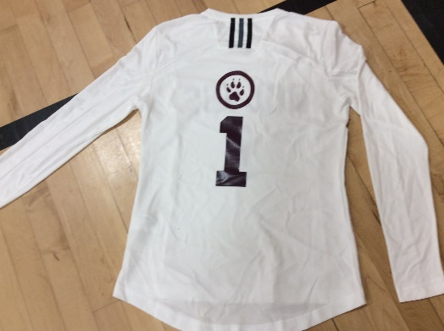
The PAC is a group of dedicated parents who work closely with the school administration in creating opportunities for students, parents and the school community.
In the past, funds have supported initiatives that are not funded through the Pembina Trails School Division.

The suggested contribution is $20.00 per student in lieu of direct sale fundraising such as chocolates or magazines.

The amounts raised through this fundraising are separate and apart from the funds raised through student fees by the school and remain the responsibility of the Parent Advisory Council (PAC).

Should any member of the school community wish to provide input into the process of deciding how the funds will be collected or allocated, they are welcome to contact us or attend one of the PAC meetings.

Thank you for your support of HGI and PAC.
Sincerely,
Jen and Quinn Wilson
PAC Co-Chairs
Jen@midworld.org & Quinn@midworld.org

✂ - - - - - - - - - - - - - - - - - - - - - - - - - - - - - - - - - - - - - - - - - - - - - - - - - - - - - - - - - - - - - - - - - -

HGI Cheque Form

- Make cheque payable (or submit online) to Henry G. Izatt PAC (Parent Advisory
- Council).
- If you have multiple children in the school, PLEASE SUBMIT ONE CHEQUE/FORM
- PER CHILD!!
- Post-date the cheque to September 1st of the upcoming school year.

Child's Name: _________________________ Grade Entering :______________________
Amount of
Cheque: _____________________________________________________________
Parent Name(s) _____________________________________________________________
_____________________________________________________________
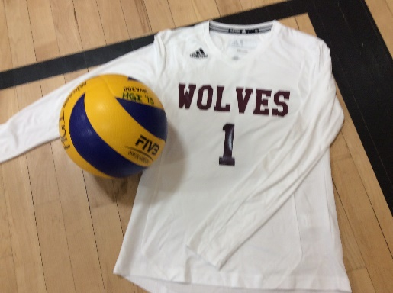
Did you know that your generous donations have helped in so many ways?
Volley ball uniforms

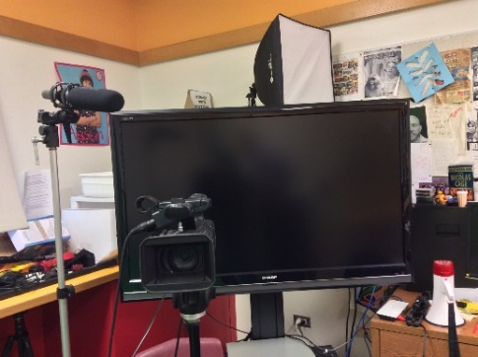
Technical equipment to support HGI Live. Be sure to check out the weekly announcement on HGI Live at:

https://goo.gl/0EPhW8
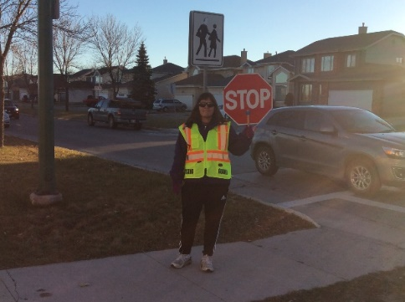
Our wonderful crossing guard - when the concern of traffic and child safety was brought to PAC, we listened. We hope that we as a PAC can continue to support this very important initiative this year as well. PAC contributes around $2,000.00 to the crossing guard program. We need your help!
If you would like PAC to support an initiative please come to a PAC meeting and let us know what is important to you.

JOIN US ON FACEBOOK! Just send a friend request to HGI Parent Advisory Group
https://www.facebook.com/groups/hgipac/
Sincerely,
Jen & Quinn Wilson PAC Co-chairs

